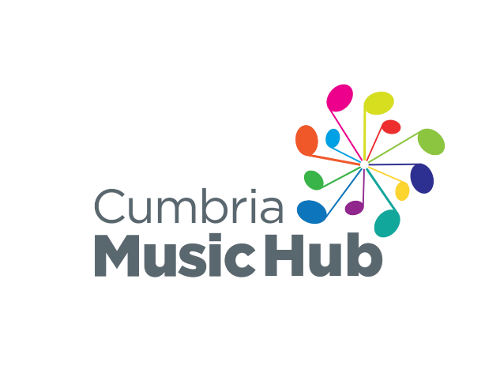


School Music Development Plan
Developing Music in your Primary School - A Self-Assessment Document

About this self-assessment document
Our thanks to Kent Music who have kindly allowed us to use and adapt this document. The document helps you to assess your current music provision and to plan and develop your school music vision moving forwards. The refreshed National Plan for Music Education, published in June 2022 recommends all schools, and MATs have a Music Development Plan in place to show their ongoing commitment to the development of music in their school or Academy Trust.
Intended audience: Headteachers, Senior Leadership Teams and School Music Leads.

How to use this document
Step 1: In collaboration with your school/department establish your vision for music

Step 2: Using the music provision self-assessment table, assess your current provision thinking about your newly created vision. Source evidence to back up your findings.

Step 3: Write a plan of action to identify how you will achieve your vision from your current position. How will you address the gaps in your provision?

Step 4: Review the impact the strategy has had on music in school and adjust your vision when necessary.

Our Vision for Music
• Music is a key part of our lives. It is everywhere and at an educational level, can provide a liquid link between a diversity of academic subjects whilst offering children something that is emotional, imaginative, creative and fun. • Music can be a truly inclusive subject and the driving force for learning. • Music stimulates brain development in children: it is a great way to enhance reading comprehension abilities in children. • Music integrates into many different subjects, e.g. Maths, History, Science etc. • Music can help to develop the skills, attitudes and attributes that can support learning in other national curriculum subjects. This includes listening skills, the ability to concentrate, memorization, math and pattern-recognition skills, creativity, intuitions, spatial intelligence (which allows them to perceive the world accurately and form mental pictures, spatial intelligence is helpful for advanced mathematics), aesthetic sensitivity, perseverance, the ability to work in a group, selfconfidence and sensitivity towards others. • Students learn to improve their work: Learning music promotes craftsmanship, and students learn to want to create good work instead of mediocre work. This desire can be applied to all subjects of study. • Increased coordination: Students who practice with musical instruments can improve their hand-eye coordination. Just like playing sports, children can develop motor skills when playing music. • A sense of achievement: Learning to play pieces of music on a new instrument can be a challenging, but achievable goal. Students who master even the smallest goal in music will be able to feel proud of their achievement. • Music builds imagination and intellectual curiosity: Introducing music in the early childhood years can help foster a positive attitude toward learning and curiosity. Artistic education develops the whole brain and develops a child’s imagination. • Responsible risk-taking: Performing a musical piece can bring fear and anxiety. Doing so teaches kids how to take risks and deal with fear, which will help them become successful and reach their potential.

High-Quality School Music Education consists of three distinct, but interlinked areas of provision:
- Curriculum music, compulsory from key stages 1-3
- Instrumental and vocal lessons, and ensemble membership.
- Musical events and opportunities, such as singing in assembly, concerts and shows, and trips to professional concerts.
The power of music to change lives:
A National Plan for Music Education (June 2022)
STEP ONE – CREATING A VISION FOR MUSIC IN YOUR SCHOOL

Why is it important
A vision allows everyone to work towards the same goal. This can often be a challenge as there are often so many areas of focus. If you lead a team, or are part of a MAT, it’s beneficial to complete this process together because it not only provides you with different opinions and ideas but also creates a more supportive environment where staff are invested in the long-term vision. If you have sole responsibility for music, you may benefit from collaborating or linking with another school. Cumbria Music Hub can help you with this if you don’t know where to start. If that is not possible or you prefer to work independently then a vision will help you to keep track of your goals and progress towards them.
It’s important to consider your school’s ethos and vision when completing your plans so that your vision aligns with the school’s overall aims.

Things to consider when creating your vision
What do you think the purpose of studying music is?
How do you want your pupils to be changed by music?
What is your ultimate goal?
How does music contribute to the school ethos?
How do you see all elements of music provision working together: 1-1 and small group tuition, whole class instrumental learning, curriculum music and music groups and ensembles.

What is a vision
In the busy day-to-day life of a School, it can be difficult to see beyond the demands of teaching your classes, dealing with students and colleagues, and managing administrative tasks. However, it is essential that you find time to step back and look at the bigger picture and spend some time reflecting on your current position and thinking about where you see music in your school in the future.
The decision that you make will become the vision for your school.

STEP TWO: MUSIC PROVISION SELF ASSESSMENT
Please use the following checklist to self-assess your school or MAT music provision.
For each category decide if your school has achieved Band 1, 2 or 3. The descriptors have been designed to work cumulatively. To meet the requirements for band three you must also meet all those for bands one and two. Additionally, you need to meet all the criteria in a band before you can say it is achieved.
The descriptors in Band 1 generally indicate that the arrangements you have in place provide the right level of entitlement and engagement for children in music, or a sufficient level of support from your school leadership for music in school. The additional Bands are ways to extend this when you are ready to do so – consider them as starting points for reflection on what would be appropriate for your setting.

Area | Category | Band | Descriptor | Achieved
Curriculum | Curriculum Design | 1 | The music curriculum is planned for in all year groups and skills are mapped progressively across Key Stages as guided by the National Curriculum (and Model Music Curriculum). | Yes
Curriculum | Curriculum Design | 2 | Additional aspects (ie: whole class music, 1-1 / small group tuition and ensembles) are embedded into the planning of the music curriculum so that they support the musical outcomes.  Composing and musical creativity is supported effectively at every level. | Yes
Curriculum | Curriculum Design | 3 | The curriculum is planned with consideration for transition taking into account the expectations of the KS3 curriculum and planning in collaboration with local secondary schools.  Music technology is used effectively to support musical learning. | Yes
Curriculum | Assessment | 1 | We use teacher assessment through the year using at least one method (video, audio, written). Teachers can assess against end of year expectations. | Yes
Curriculum | Assessment | 2 | We use teacher assessment at planned points throughout the year using a variety of methods (video, audio, written etc.) to track pupil progress. | Yes
Curriculum | Assessment | 3 | We use a range of formative and summative assessment strategies confidently. There are numerous opportunities for pupils to receive feedback on their performance/progression, and for self and peer assessment. | Yes
Curriculum | Timetabling | 1 | There is a dedicated curriculum music time on the school timetable each week for all year groups. The NPME recommends a minimum of 1 hour of music teaching a week. This may take the form of short sessions spread across the week. | Yes
Curriculum | Timetabling | 2 | Additional activities such as whole class instrumental lessons or singing (e.g. in assemblies) are timetabled in addition to dedicated curriculum time. | Yes
Curriculum | Timetabling | 3 | Continuation of whole class instrumental lessons via small group or 1-1 tuition is scheduled within the school day. | Yes

Area | Category | Band | Descriptor | Achieved
Tuition and Ensembles | Instrumental and vocal tuition | 1 | Every child has an opportunity to learn an instrument and to make progress with instruments.  Schools engage with specialist music teacher to provide 1-1 and small group tuition on at least 1 instrument.  Up to 10% of the school population engage in instrumental tuition. | Yes
Tuition and Ensembles | Instrumental and vocal tuition | 2 | Schools engage with a specialist teacher to provide 1-1 and small group tuition covering at least 2 different instruments.  School engages in live performances for all pupils to raise awareness of instrumental families highlighting opportunities for additional musical learning. | Yes
Tuition and Ensembles | Instrumental and vocal tuition | 3 | Schools engage with a specialist teacher to provide 1-1 and small group tuition covering at least 2 instrumental families.  Over 15% of the school population engage in instrumental tuition.  Pupils perform in both formal and informal settings regularly (at least once per term).  School regularly engages and plans with their peripatetic teachers allowing for a consistent approach to music provision. | Yes
Tuition and Ensembles | Whole class activity | 1 | Children in EYFS/KS1 have opportunities to explore simple class instruments such as hand or tuned percussion and recorders.  Whole Class Instrumental Learning is delivered for at least one term for every child in one KS2 year group. This may be delivered in smaller groups or as a class.  There is a clear instrumental progression route from Whole Class Instrumental Learning such as smaller group and/or ensemble tuition.  The school ensures there is an appropriate adult always supervising the Whole Class Instrumental Learning class. | Yes
Tuition and Ensembles | Whole class activity | 2 | Whole Class Instrumental Learning is delivered for at least a year for every child in one KS2 year group.  The school has selected an instrument Whole Class Instrumental Learning that promotes musical progression for their pupils.  The school communicates effectively with the Whole Class Instrumental Learning teacher (if external) to develop a shared understanding of purpose and progression.  The school/teacher ensures there is an opportunity for performance to parents and peers at the end of the Whole Class Instrumental Learning year.  10% of students choose to continue learning an instrument after Whole Class Instrumental Learning. | Yes
Tuition and Ensembles | Whole class activity | 3 | Whole Class Instrumental Learning is planned to successfully integrate into the school’s music curriculum.  The class teacher participates fully in Whole Class Instrumental Learning lessons (if not delivering themselves).  The school/teacher ensures there are opportunities throughout the year to showcase the Whole Class Instrumental Learning class to their peers.  15% of students choose to continue learning an instrument after the Whole Class Instrumental Learning year. | Yes
Tuition and Ensembles | Instrumental Ensemble Provision | 1 | The school provides an opportunity for ensemble playing for at least a term.  The ensemble is regularly attended by a minimum of 5 pupils.  The ensemble is led by a competent musician. | Yes
Tuition and Ensembles | Instrumental Ensemble Provision | 2 | School provides ensemble opportunities throughout the year that cater for all instruments learnt by pupils at the school.  The ensemble is regularly attended by a minimum of 10 pupils.  It is planned that the ensemble rehearses and performs a range of styles and genres.  There is an opportunity for the ensemble to perform to parents or peers. | In progress
Tuition and Ensembles | Instrumental Ensemble Provision | 3 | Effective planning is in place for the ensemble to rehearse and perform a wide range of styles and genres.  There are many opportunities for the ensemble to perform to parents or peers. | In progress

Area | Category | Band |  | Descriptor |  | Achieved
Singing | Singing Provision | 1 |  | There are termly opportunities for massed singing; these may be linked with calendar events or performance opportunities.  Singing is a core part of the school’s music curriculum and children’s musicianship development. |  | Yes
Singing | Singing Provision | 2 |  | There are weekly singing assemblies for all pupils. |  | Yes
Singing | Singing Provision | 3 |  | There is 1 or more weekly singing assembly for all pupils lead by a specialist.  All staff are upskilled and confident at leading singing in their classrooms. |  | Yes
Singing | Choirs | 1 |  | There is a school choir and/or vocal ensemble that rehearses weekly. |  | Yes
Singing | Choirs | 2 |  | The school choir/vocal ensemble is led by either a specialist teacher or a competent member of staff who has expertise of leading vocal work and practices healthy singing. |  | Yes
Singing | Choirs | 3 |  | The school has multiple choirs/vocal ensembles (supporting different stages of vocal development). |  | No
Singing | Staff Singing | 1 |  | There is a person responsible for singing in the school. |  | Yes
Singing | Staff Singing | 2 |  | There are singing opportunities for staff such as a choir/vocal group |  | Yes
Singing | Staff Singing | 3 |  | All staff are upskilled and confident to lead healthy singing in their classes. |  | Yes
Area | Category |  | Band |  | Descriptor | Achieved
School life and opportunities | Leadership and advocacy |  | 1 |  | There is a designated member of school staff, not a senior leader (where staff numbers allow), who has responsibility for music and advocates for the subject across the school. | Yes
School life and opportunities |  |  | 2 |  | In collaboration with the designated music leader, senior leaders drive the development of music across the school and advocate for the importance of music in school life. The time designated for music leadership reflects not only responsibility for curriculum music, but co-curricular provision, experiences, and performances. | Yes
School life and opportunities |  |  | 3 |  | A named governor takes responsibility for monitoring music (arts); as a result, music is an integral part of daily school life. | Yes
School life and opportunities | Pupil Voice |  | 1 |  | Pupil voice is taken into consideration when planning internal school events through informal discussions. | Yes
School life and opportunities |  |  | 2 |  | Pupil voice is taken into consideration when planning for participation in external events either through informal discussion or student council. | Yes
School life and opportunities |  |  | 3 |  | Pupil voice is taken into consideration when planning for the music curriculum, this could include repertoire selection or instruments of interest. | No
School life and opportunities | Value of Music |  | 1 |  | Music occasionally plays a role in school life. | Yes
School life and opportunities |  |  | 2 |  | Music is an important part of school life. | Yes
School life and opportunities |  |  | 3 |  | Music is an integral part of the everyday life of the school and wider community. | Yes
School life and opportunities | Inclusion |  | 1 |  | Every child is included and supported in accessing musical learning and experiences  All music lessons are planned to use instruments/resources that are accessible and age appropriate to their students.  All members of staff and external providers teaching music have an awareness of the pupil needs in the class  Students have opportunities to listen to music from a range of cultures and traditions in all key stages | Yes
School life and opportunities |  |  | 2 |  | The school plans to target students eligible for pupil premium and supports these students to engage in musical opportunities and tuition through this funding. The school signposts learners to music bursary and funding schemes.  The school provides additional support though resources to enhance accessibility.  All teachers and staff know when and how to differentiate appropriately using approaches which enable pupils to be taught effectively.  Students have opportunities to listen to and actively engage with music from a range of cultures and traditions in all key stages. | Yes
School life and opportunities |  |  | 3 |  | Bespoke financial support is applied so that all pupils can access the curriculum and extra-curricular opportunities.  School provides access to alternative/adaptive instruments where necessary.  Annual planning demonstrates a secure understanding of how a range of factors can inhibit pupils’ ability to learn and how best to overcome these.  Schools signpost opportunities for students and make families aware of the benefits of supporting musical learning.  Students have opportunities to listen to and interact with music from a wide range of cultures and traditions in all key stages. Students experience a range of musical role models including disabled musicians and a range of backgrounds and ethnicities. | Yes
School life and opportunities | Resources and equipment (physical) |  | 1 |  | There are limited instrumental resources within the school, possibly only untuned percussion or a part set of class instruments. | Yes
School life and opportunities |  |  | 2 |  | There are a range of instruments within the school, including whole class sets of instruments (owned or hired).  The school has access to and uses teaching resources to support music teaching and learning (this could include online resources).  The school works with the Music Hub to facilitate access to high-quality instruments and equipment where needed. | Yes
School life and opportunities |  |  | 3 |  | There is a dedicated space for music within the school. This is equipped with a range of tuned and un-tuned instruments and technology is available for use.  The school successfully integrates the use of teaching resources (this could include online resources) into its curriculum planning. | Yes
School life and opportunities | Budget |  | 1 |  | There is limited budget for music provision. | Yes
School life and opportunities |  |  | 2 |  | The budget is planned to support the delivery of the music curriculum and supports resourcing the school. | Yes
School life and opportunities |  |  | 3 |  | There is a significant budget that is planned to support the delivery of music curriculum as well as providing students with ample opportunity to broaden their musical experiences. | In progress
School life and opportunities | CPD |  | 1 |  | The lead member of staff for music undertakes music specific CPD every year. | Yes
School life and opportunities |  |  | 2 |  | The lead member of staff is given opportunities by the school to share and upskill other staff members as a result of their CPD attendance. | In progress
School life and opportunities |  |  | 3 |  | The lead member of staff sources bespoke CPD opportunities for the school to enable quality music provision to become embedded in school life. | No
School life and opportunities | Partnerships |  | 1 |  | The school can demonstrate that it is using arts and cultural professionals and organisations to support the delivery of quality provision. The school is exploring opportunities to work in partnership with other settings. | Yes
School life and opportunities |  |  | 2 |  | The school is working in partnership with other settings, sharing resources and good practice. The school is engaged with their local Music Education Hub (including completion of the annual survey and regular attendance at network meetings). | Yes
School life and opportunities |  |  | 3 |  | The school can demonstrate over time that it has established long-lasting partnerships with arts and cultural organisations that are having a positive impact on outcomes for a wider group of children, young people, and staff. This could include Arts Mark and Music Mark accreditation.  The school is aware of local and national progression routes and signposts these to pupils effectively | Yes
School life and opportunities | Live performances |  | 1 |  | There is an opportunity for every child to enjoy live performance at least once a year. | Yes
School life and opportunities |  |  | 2 |  | Opportunities to enjoy live music as an audience member include large-scale performances, small-scale workshops, professional, amateur, within school and between schools. | Yes
School life and opportunities |  |  | 3 |  | Live music performances provide links to curriculum learning and progression routes, such as local secondary schools or ensembles. Pupils enjoy a range of music that reflects their interests and passions. | In progress
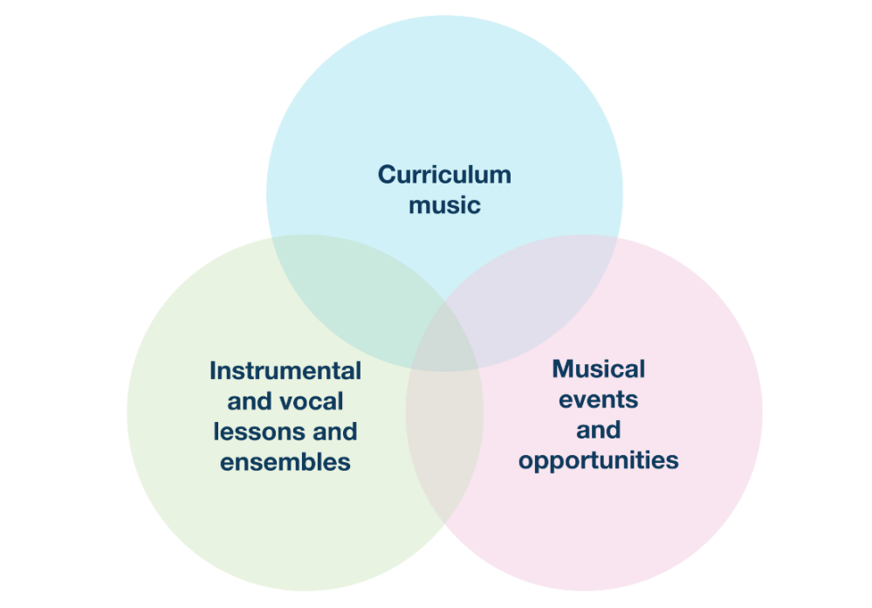
Notes

STEP THREE: PLAN OF ACTION
Reflect on your findings from the self-assessment process. Take some time to select between one and four areas for development and however many categories you need to develop which you can detail in the drop-down boxes below.
Create a plan using the table which will support you as you develop your selected areas. This plan could be linked with the School Improvement Plan (SIP) or could be part of your own departmental plans.
If you would like additional support with creating your plan you are welcome to contact Cumbria Music Hub. We also offer a range of CPD opportunities for music teachers across Cumbria. Please do visit our website for more information on what courses are on offer.

Area | Category | Actions  Meaningful tasks that contribute towards achieving the given objective | Deadline | KPIs/Evaluation Criteria  Ways of monitoring progress/ achieving your objective | RAG
Tuition and Ensembles | Instrumental Ensemble provision | Recorder ensemble is given a range if genres and styles to learn. | JULY 2027 | Evidence of pieces of music that the children have enjoyed.
School Life and Opportunities | Live Performances | Children have opportunity to watch a live performance of an instrumental group | JULY 2027 | Either or have both had an ensemble in school to perform, have visited the secondary schools to watch a live performance.
Tuition and Ensembles | Instrumental Ensemble provision | Recorder group get the opportunity to perform to parents | JULY 2027 | Evidence that his has happened.
Click to choose an area | Click for a category
Click to choose an area | Click for a category

STEP FOUR: REVIEW
Once you have had time to work on some of your focus areas, review your original self-assessment and alter bands accordingly based on the improvements you have made over the year.
It is at this point where you can choose to create yourself new targets to support the development of music provision in other areas or continue working towards your current targets if there is still work needed.

Area | Category | Actions  Meaningful tasks that contribute towards achieving the given objective | Deadline | KPIs/Evaluation Criteria  Ways of monitoring progress/ achieving your objective | RAG
Click to choose an area | Click for a category
Click to choose an area | Click for a category
Click to choose an area | Click for a category
Click to choose an area | Click for a category
Click to choose an area | Click for a category
Click to choose an area | Click for a category

As part of the Music Hub’s funding agreement with Arts Council England (ACE), the Hub Lead Organisation is required to monitor schools’ engagement and the effectiveness of our programmes. In return for the provision of this School Music Development Plan template and guidance, please support our reporting by answering the two questions below and submitting through our online form.
1. | In what stage of development is your School Music Development Plan?  Please note that if you have completed this template document and it has been adopted by your school, then your SMDP is Established. This question also applies where you have used your own SMDP format.
 | Established | The SMDP has been written/created and is being delivered in this establishment, and mechanisms may be in place for ongoing review and improvement. This also includes establishments within a Multi Academy Trust which are delivering a plan that is in place for the whole trust.
 | In Development | The SMDP is in the process of being created. It is not yet being delivered in this establishment but aims to be delivered within the current or following academic year. This also includes establishments within a Multi Academy Trust where a plan for the whole trust is in development.
 | Development Pending | The establishment has not yet begun to create a SMDP but has indicated intent to create an SMDP within the following academic year. This also includes establishments within a Multi Academy Trust where a plan for the whole trust is pending development.
 | No intent around SMDP | The establishment does not have a SMDP in development or pending. It has been confirmed that the establishment does not currently intend to create a SMDP.
 | Not Known | Stage of development for the SMDP in this establishment is not known.

2. | How embedded is the Model Music Curriculum (or equivalent) in your school/establishment?  (N.B. – ‘Equivalent’ refers to a curriculum that is at least comparable in breadth and ambition.)
 | Established | The MMC (or equivalent) has been adopted and is being delivered in this establishment in all relevant year groups/Key Stages. Mechanisms may be in place for ongoing review and refinement. This also includes establishments within a Multi Academy Trust which are delivering a music curriculum that is in place for the whole trust.
 | Partially Established | The MMC (or equivalent) has been adopted and is being delivered in this establishment in some but not all relevant year groups/Key Stages. Plans may be in place to expand across all year groups/Key Stages. This also includes establishments within a Multi Academy Trust which are delivering a music curriculum that is in place for some but not all year groups/Key Stages for the whole trust.
 | In Development | The MMC (or equivalent) is in the process of being adopted. It is not yet being delivered in this establishment but there is an intention to implement it this or next academic year. This also includes establishments within a Multi Academy Trust where a music curriculum for the whole trust is in development.
 | No intent around MMC (or equivalent) | The establishment has not adopted the MMC (or equivalent). It has been confirmed that the establishment does not currently intend to do so.
 | Not Known | How embedded the MMC (or equivalent) is in this establishment is not known

