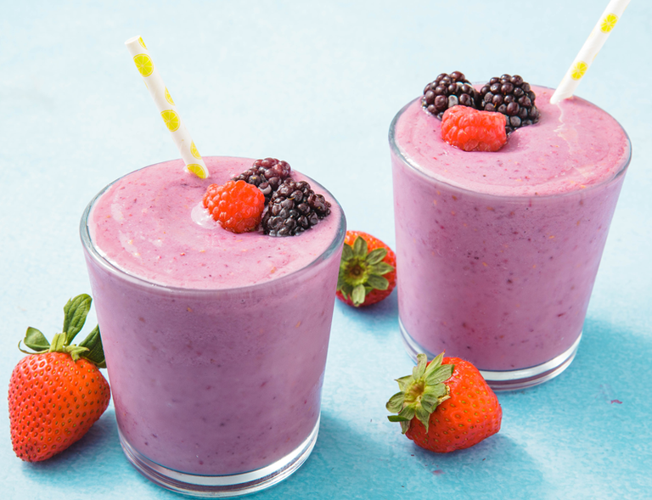Healthy Fruit smoothie recipe by ___SJ

|  |  |
| --- | --- |
| **Introduce your recipe.** What is good about it? Can you persuade others to try it? | Make a creamy smoothie! |
| The ingredients (food) you will need are: | 1. Frozen strawberrys 2. Yogurt (healthy if wanted) 3. Fruit (any of choice) 4. oats |
| The equipment your will need are: | 1. blender 2. knife 3. Cutting board |
| Method. The steps to make your smoothie. | 1. Add the oats and blend them until they’re like dust 2. Get the frozen strawberries cut the stem off then cut them into three peices. 3. Get the extra fruit and also cut them up 4. Put the fruit, strawberries, yogur and oats in the blender      1. Blend and put into cup |