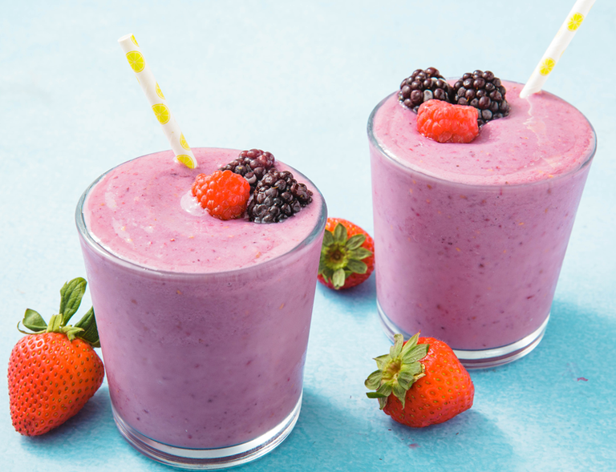Healthy Fruit smoothie recipe by mya___________________

|  |  |
| --- | --- |
| **Introduce your recipe.** What is good about it? Can you persuade others to try it? | It might taste nice .  Yes because they might like to make it if they like it . |
| The ingredients (food) you will need are: | 1. Rasberries 2. Blueberries 3. Blackcurrent |
| The equipment your will need are: | 1. Smoothy blender 2. cup 3. Jug |
| Method. The steps to make your smoothie. | Cut the fruit   1. Cup full of fruit 2. Put it in the smoothy blender 3. Por it in the jug |