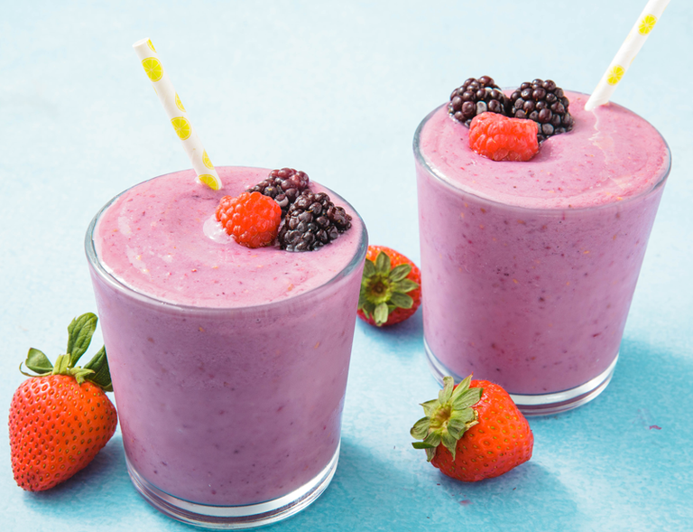Healthy Fruit smoothie recipe by Matthew Bainbridge

|  |  |
| --- | --- |
| **Introduce your recipe.** What is good about it? Can you persuade others to try it? | Healthy Strawberry & Apple Smoothie  Healthy and no added sugar recipe |
| The ingredients (food) you will need are: | 1. 1 apple 2. 300g Strawberry 3. 100g Oats 4. 400g Yoghurt 5. 250ml milk |
| The equipment your will need are: | 1. blender 2. Spoon 3. Knife 4. Weighing scales 5. Measuring jug 6. Grater 7. Glasses |
| Method. The steps to make your smoothie. | 1. Firstly, measure 100g of oats and blend 2. Next, put the 300g of strawberries in the blender 3. Then grate the apple and add to the blender 4. Add all the yoghurt and milk to the blender 5. Blend till it’s a smooth consistency 6. Pour your smoothie into glasses and enjoy! 7. (Add honey for more sweetness) |