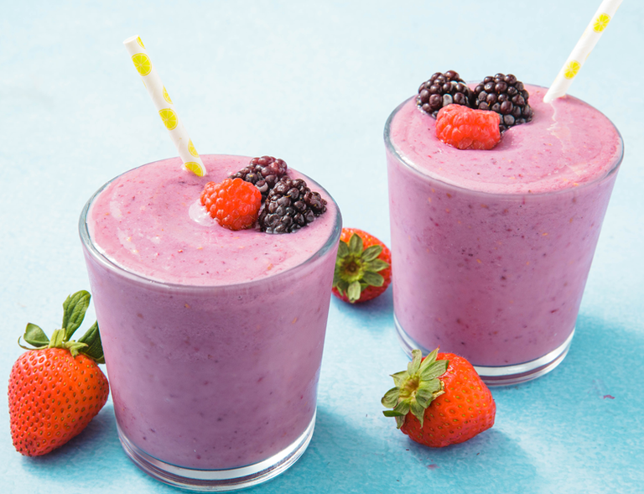Healthy Fruit smoothie recipe by _Jacob Hall__________________

|  |  |
| --- | --- |
| **Introduce your recipe.** What is good about it? Can you persuade others to try it? | Agent Peely smoothie |
| The ingredients (food) you will need are: | 1. 1 banana 2. 1 tablespoon honey 3. 4 ice cubes 4. 2 strawberries 5. 240ml fresh apple juice |
| The equipment your will need are: | 1. Blender 2. Knife 3. Chopping board 4. Glass 5. Straw |
| Method. The steps to make your smoothie. | 1. Chop up the banana on your chopping board 2. Then chop the strawberries in half 3. Add the banana and strawberries to the blender with the apple juice 4. Next put in the ice cubes, apple juice and honey 5. Blend up the ingredients until smooth 6. Pour the smoothie into your glass, add the straw and enjoy! |