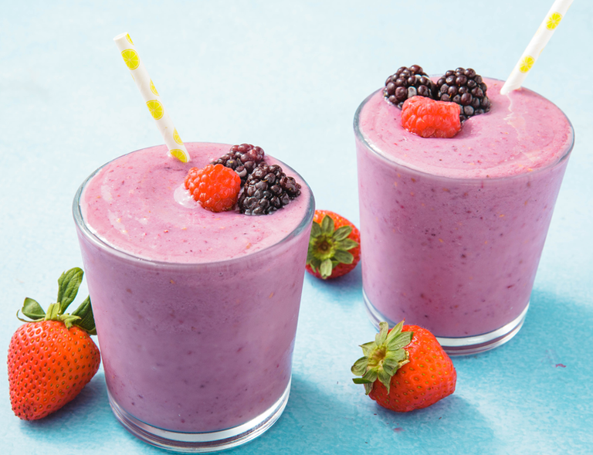Healthy Fruit smoothie recipe by emily___________________

|  |  |
| --- | --- |
| **Introduce your recipe.** What is good about it? Can you persuade others to try it? | It’s healthy but good and tasty at the same time and also has really nice fruit. |
| The ingredients (food) you will need are: | 1. banana 2. Coconut milk 3. blueberries 4. A squeeze of lemon and fat free yogurt. |
| The equipment your will need are: | 1. blender 2. knife 3. Lemon squeezer 4. scale |
| Method. The steps to make your smoothie. | 1. Cut the banana into small pieces 2. Pour 250ml of coconut milk and 100ml of fat free yogurt 3. Now wash your blueberries and measure 150 grams then place in your blender 4. Now squeeze some lemon and maybe honey if u want and blend. |