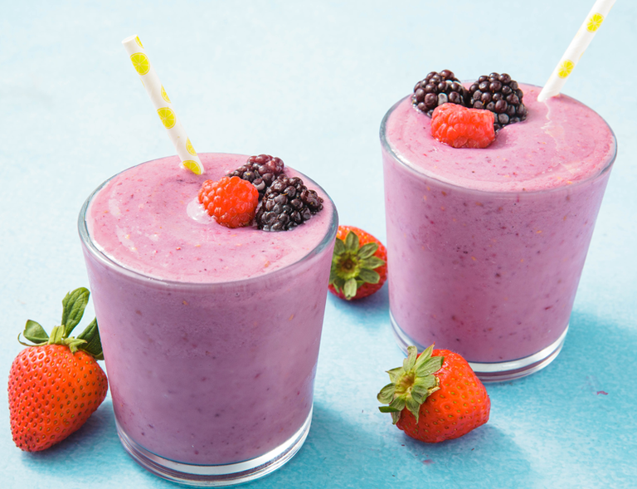Healthy Fruit smoothie recipe by CK

|  |  |
| --- | --- |
| **Introduce your recipe.** What is good about it? Can you persuade others to try it? | This is The Berry Banana Smoothie, it's healthy but still has all the great taste of fresh fruit and cream. |
| The ingredients (food) you will need are: | 1. 100g of grapes 2. 100g of strawberries 3. 50g of blackberries 4. Half a banana 5. 100g raspberries 6. 200ml of semi skimmed milk 7. 100g of vanilla ice cream |
| The equipment you will need are: | 1. Knife 2. Chopping board 3. Spoon 4. Weighing scales 5. Measuring jug |
| Method. The steps to make your smoothie. | 1. Wash Your Hands! 2. Peel your banana then cut it in half. 3. Wash and remove the green tops on the strawberries. 4. Wash your raspberries, grapes and blackberries. 5. Put all your berries into the blender. 6. Cut your half a banana into little circles. 7. Add the bits of banana into the blender. 8. Add the ice cream and milk to the blender. 9. Blend it all together. 10. Pour it into glasses. 11. Enjoy! |