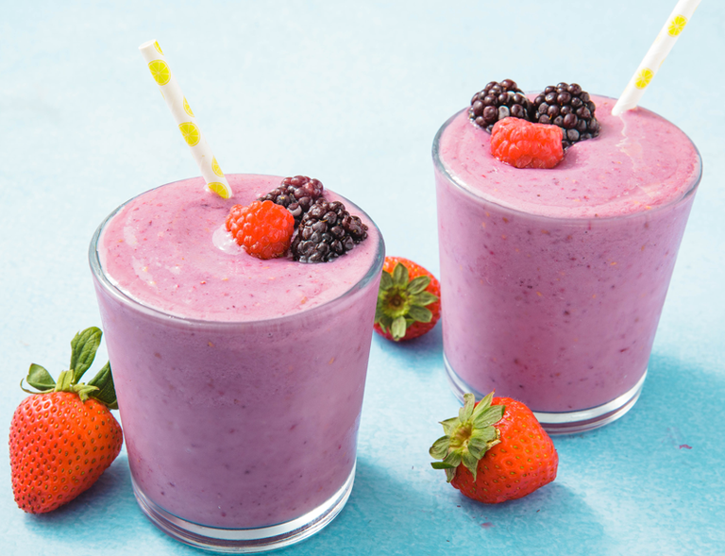Healthy Fruit smoothie recipe by Ciaran

|  |  |
| --- | --- |
| **Introduce your recipe.** What is good about it? Can you persuade others to try it? | Apple and banana smoothie you should try it. It will make you fit and healthy whilst tasting delicious |
| The ingredients (food) you will need are: | 1. 1 Apple 2. 1 banana 3. Half a teaspoon of honey 4. 240ml of semi skimmed milk |
| The equipment your will need are: | 1. Weighing scales 2. blender 3. Measuring jug 4. Knife and chopping board |
| Method. The steps to make your smoothie. | 1. First carefully Wash the apple and chop the fruit and put it in the blender 2. Next add the milk to the mixture 3. Then add the honey and blend until smooth   4. Finally pour into a cup and have a taste! |