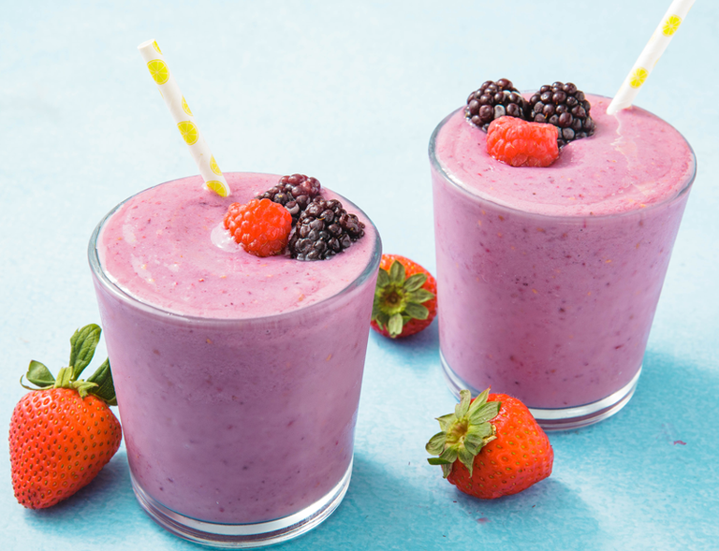Healthy Fruit smoothie recipe by __Charlie Hall______________

|  |  |
| --- | --- |
| **Introduce your recipe.** What is good about it? Can you persuade others to try it? | Banana larma smoothie |
| The ingredients (food) you will need are: | 1. Banana 2. 1 tablespoon of Honey 3. 240ml Milk 4. 1 scoop Vanilla ice cream 5. 1 tablespoon of nutella |
| The equipment your will need are: | 1. Blender 2. knife 3. glass 4. Chopping board 5. Spoon 6. straw |
| Method. The steps to make your smoothie. | 1. First peel your banana, then chop into slices on your chopping board. 2. Get your blender, put your sliced banana in 3. Add 240ml of milk, a scoop of ice cream to the banana. 4. Now put one tablespoon of nutella and the honey in as well 5. Blend this altogether for 30 seconds or until smooth 6. Pour the Banana Larma Smoothie into your glass and add the straw…….enjoy!!:) |