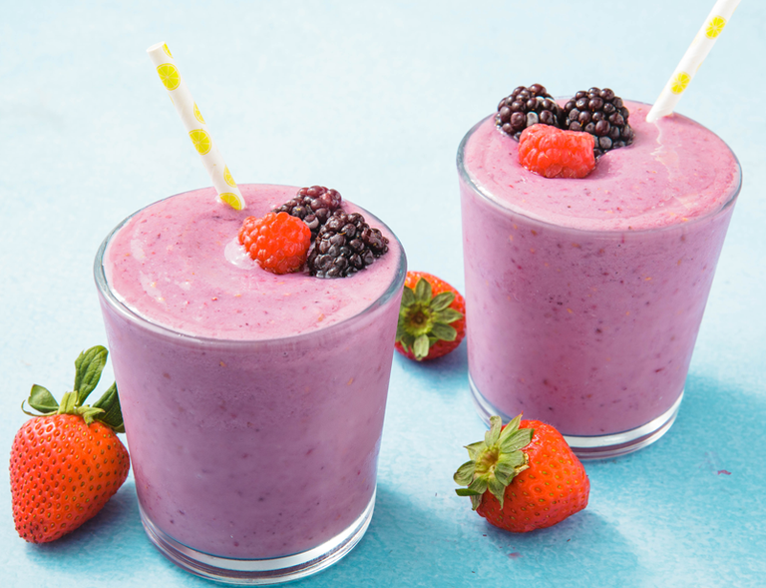Healthy Fruit smoothie recipe by _Ben Dickson_

|  |  |
| --- | --- |
| **Introduce your recipe.** What is good about it? Can you persuade others to try it? | Healthy banana and strawberry smoothie, great way to start the day! |
| The ingredients (food) you will need are: | 1. 25g Porridge Oats 2. 1 banana 3. 200g Strawberries 4. 120ml milk 5. 120ml natural yoghurt |
| The equipment your will need are: | 1. Blender 2. Knife 3. Weighing scales 4. Chopping board 5. Measuring jug |
| Method. The steps to make your smoothie. | 1. Firstly you will need 25g of porridge oats. Put them into the blender and blend them till they are smaller. 2. Secondly, you will need to peel and chop into small pieces the banana. Then place into the blender. 3. Next, add your strawberries, milk and yoghurt into the blender. 4. Finally, blend it all together and pour it into a glass. 5. Enjoy! |