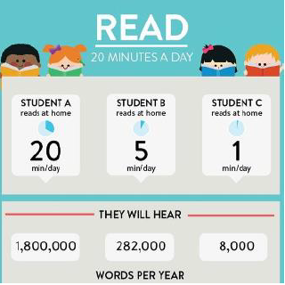

Dear Parents/Carers,

Parents have an important role to play in helping their children to become better readers and to enjoy reading. Reading with children at home improves their progress and development (see the above picture about the benefits of reading to expand vocabulary). Therefore, we would like you to read with your child each day if possible.

**Please can you sign your child’s reading record to show that you have heard your child read.**

This just needs to be a simple comment e.g. lovely reading… which is then signed.

Please can reading folders be brought into school each day, as they are needed for class reading activities.

Each time the children read at home, they will be given a ‘raffle ticket.’ These tickets will be entered into a raffle, which will be drawn each Friday. A small prize will be given for the winning ticket. Please encourage your child to read to you at home often, so they have lots of chances to win the raffle.

**Top tips for reading with your child**:

1. Make time to read - even ten minutes a day.

2. Find somewhere quiet without any distractions - turn off the TV/radio/computer.

3. Talk about the book- asking your child questions from their reading bookmark.

4. You can read anytime, anywhere!

5. Children don’t just have to read their school book. They can read anything they wish e.g. a menu, a magazine, shop signs.

6. Read to your child, so they can listen to how a text is read and explained.

Thanks for your help at home!

Mrs Jones

Class 3